Experiment - 14
Exploring Pro-Code Extension of a Zoho Creator Application using Custom Functions
SAI PRANAV B.V.
241401088 CSBS
AIM
To explore how pro-code capabilities can extend a low-code Zoho Creator application by creating and executing a custom Deluge function in the Patient Appointment & Scheduling Management application.
INTRODUCTION
Low-code platforms allow applications to be developed using visual components such as forms, reports, dashboards and workflows, with minimal hand-written code. This makes application development faster and easier for standard business requirements.
When standard low-code functionality is insufficient for a particular requirement, pro-code extensions allow developers to introduce programmable logic into the application. Zoho Creator supports this through Deluge, its scripting language, and through custom functions, which are reusable units of Deluge code that can be called when required.
In this experiment, a simple custom function named CheckAppointmentRequest was created for the Patient Appointment & Scheduling Management application. The function was saved and executed to understand how a pro-code extension is created and run in Zoho Creator.
PRO-CODE EXTENSION IN ZOHO CREATOR
Extending a low-code application with custom functions allows the visual structure of the application to be retained while specific application logic can be implemented using code.
The main concepts are:
- Custom Functions: Named and reusable functions created in the Functions section of the Workflow area. A function can have a name, namespace, return type and optional arguments.
- Deluge Scripting: Deluge is the scripting language used in Zoho Creator for implementing programmable application logic.
- Reusable Application Logic: A function can be written once and called whenever its logic is required, reducing repeated code.
- Custom Business Logic: Application-specific rules that are not directly available through standard configuration can be implemented using functions.
- Automation and Extensibility: Custom functions extend the capabilities of standard low-code components and provide additional flexibility.
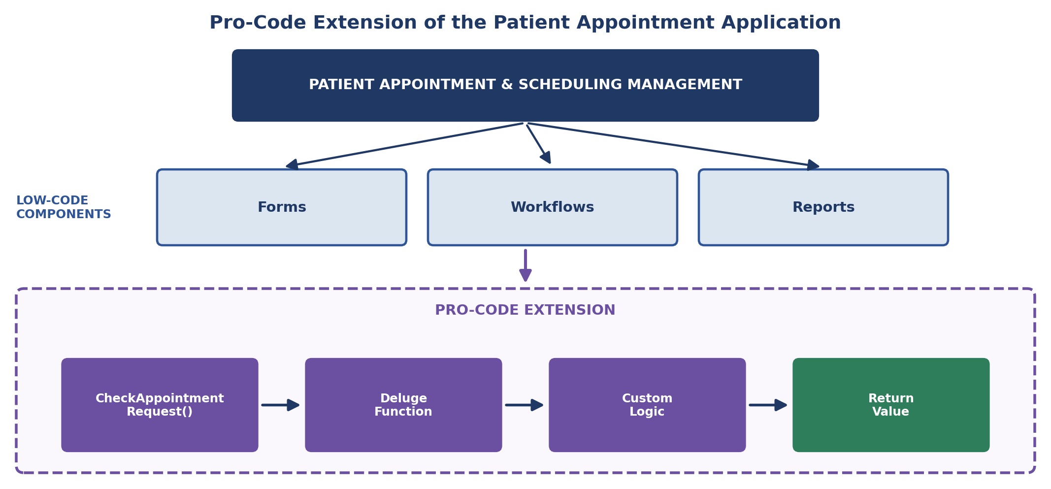
Figure 1: Pro-Code Extension of the Patient Appointment Application
PROCEDURE
1. Open the Application
The Patient Appointment & Scheduling Management application was opened in Zoho Creator in Edit mode.
2. Navigate to Functions
The Workflow section was opened and the Functions section was selected.
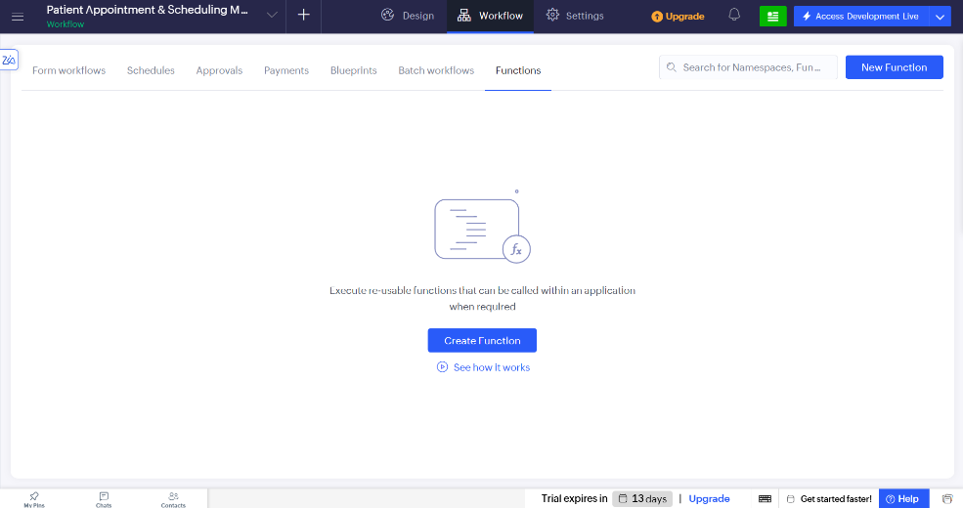
Screenshot 1 — Functions section of the Workflow area

3. Create a New Function
The Create Function option was selected. The function configuration requires the function name, programming language, namespace, return type and arguments.
The following configuration was used:
Property | Value
Function Name | CheckAppointmentRequest
Language | Deluge
Namespace | Default
Return Type | string
Arguments | None

4. Write the Deluge Function
After creating the function, the Deluge editor generated the function declaration. The following custom logic was entered:
string CheckAppointmentRequest()
{
return "Patient Appointment Request function executed successfully.";
}
The function does not require any arguments. It simply returns a confirmation message when executed.
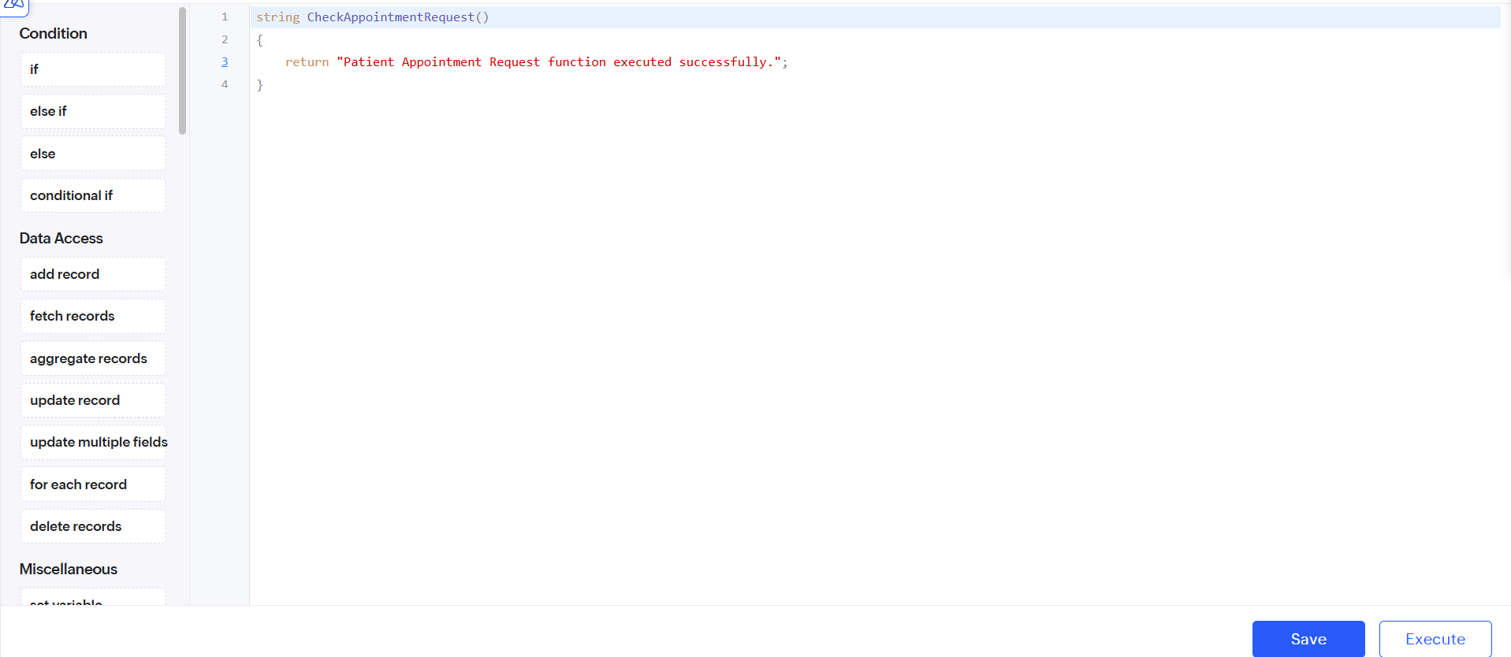
Screenshot 2 — Deluge editor showing the CheckAppointmentRequest() function

5. Save the Function
The function was saved using the Save option.
6. Execute the Function
The Execute option was selected from the Deluge function editor.
7. Verify Execution
The execution result displayed “Executed Successfully” along with the expected return value:
Patient Appointment Request function executed successfully.
The function was also visible in the Functions section after saving. This follows the same creation, execution and verification procedure demonstrated in the sample experiment.
CUSTOM FUNCTION IMPLEMENTATION
The custom Deluge function used in the experiment was:
string CheckAppointmentRequest()
{
return "Patient Appointment Request function executed successfully.";
}
The function is declared with a string return type and does not accept any arguments. When called, it returns a confirmation message indicating that the custom function was executed successfully.
The implementation demonstrates the basic structure of a custom Deluge function without introducing unnecessary application complexity.
FUNCTION EXECUTION
The custom function was executed using the Execute option in the Deluge editor.
The execution window displayed: Executed Successfully
and returned: Patient Appointment Request function executed successfully.
This confirms that the function was successfully created, saved and executed in the Patient Appointment & Scheduling Management application.
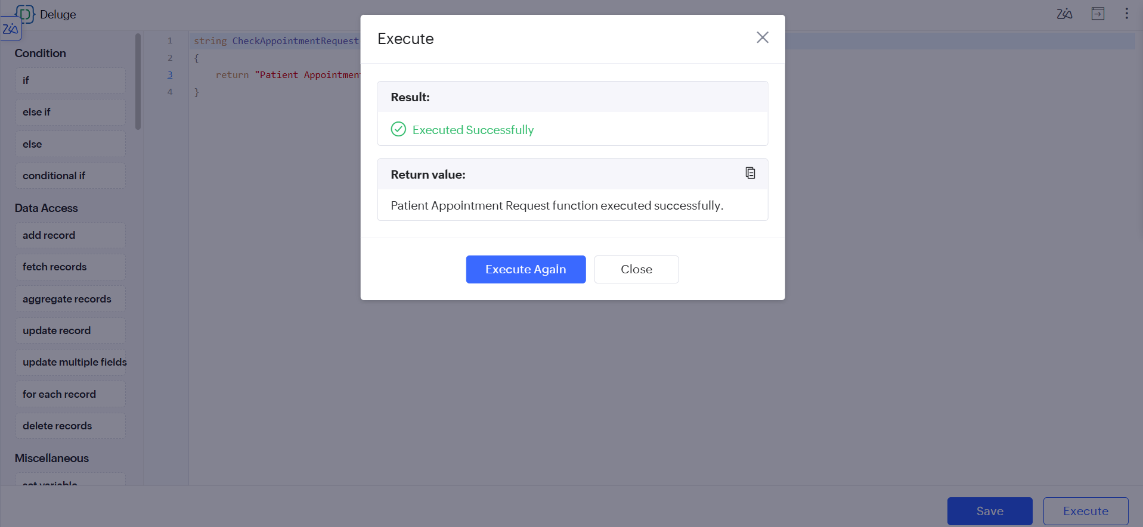
Screenshot 3 — Execution of the CheckAppointmentRequest() custom function

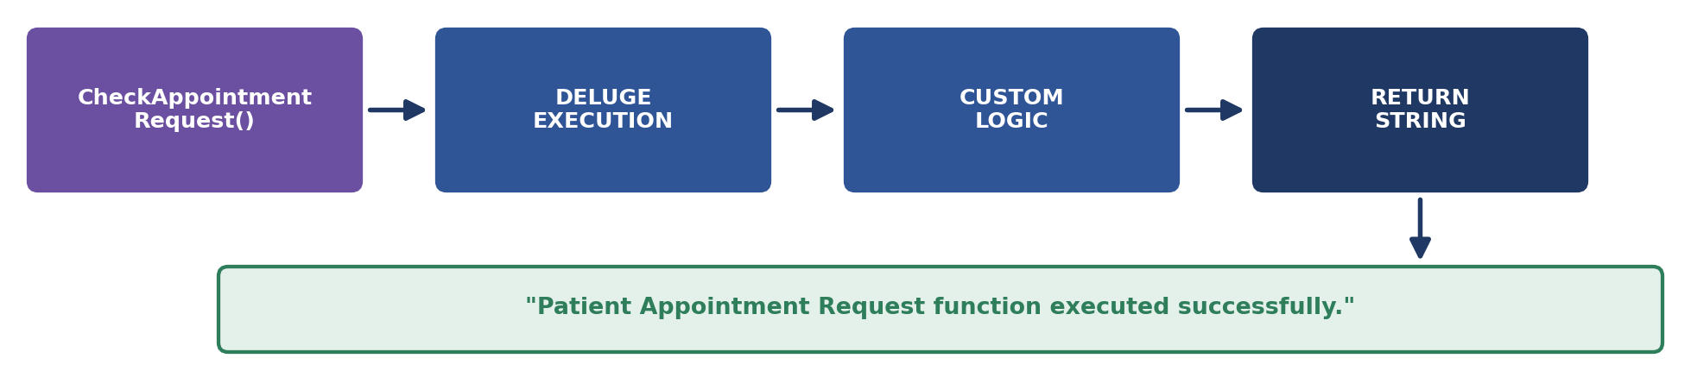
Figure 2: Function Execution Concept
EXECUTION FLOW
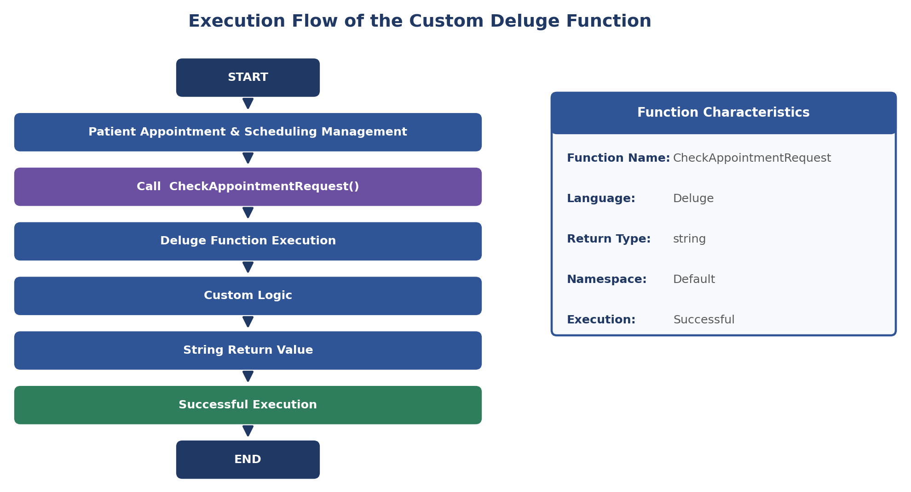
Figure 3: Execution Flow of the Custom Deluge Function
The execution flow demonstrates the sequence followed by the custom function:
1. The Patient Appointment application contains the custom function.
2. CheckAppointmentRequest() is executed.
3. The Deluge function processes its custom logic.
4. The function generates a string return value.
5. Successful execution is displayed by Zoho Creator.
LOW-CODE AND PRO-CODE EXTENSION
Low-code components provide the basic structure of the Patient Appointment & Scheduling Management application, while pro-code extensions allow additional programmable logic to be introduced when required.
Low-Code | Pro-Code
Forms | Deluge functions
Reports | Custom logic
Workflows | Advanced processing
Standard automation | Reusable functions
Visual development | Programmable automation

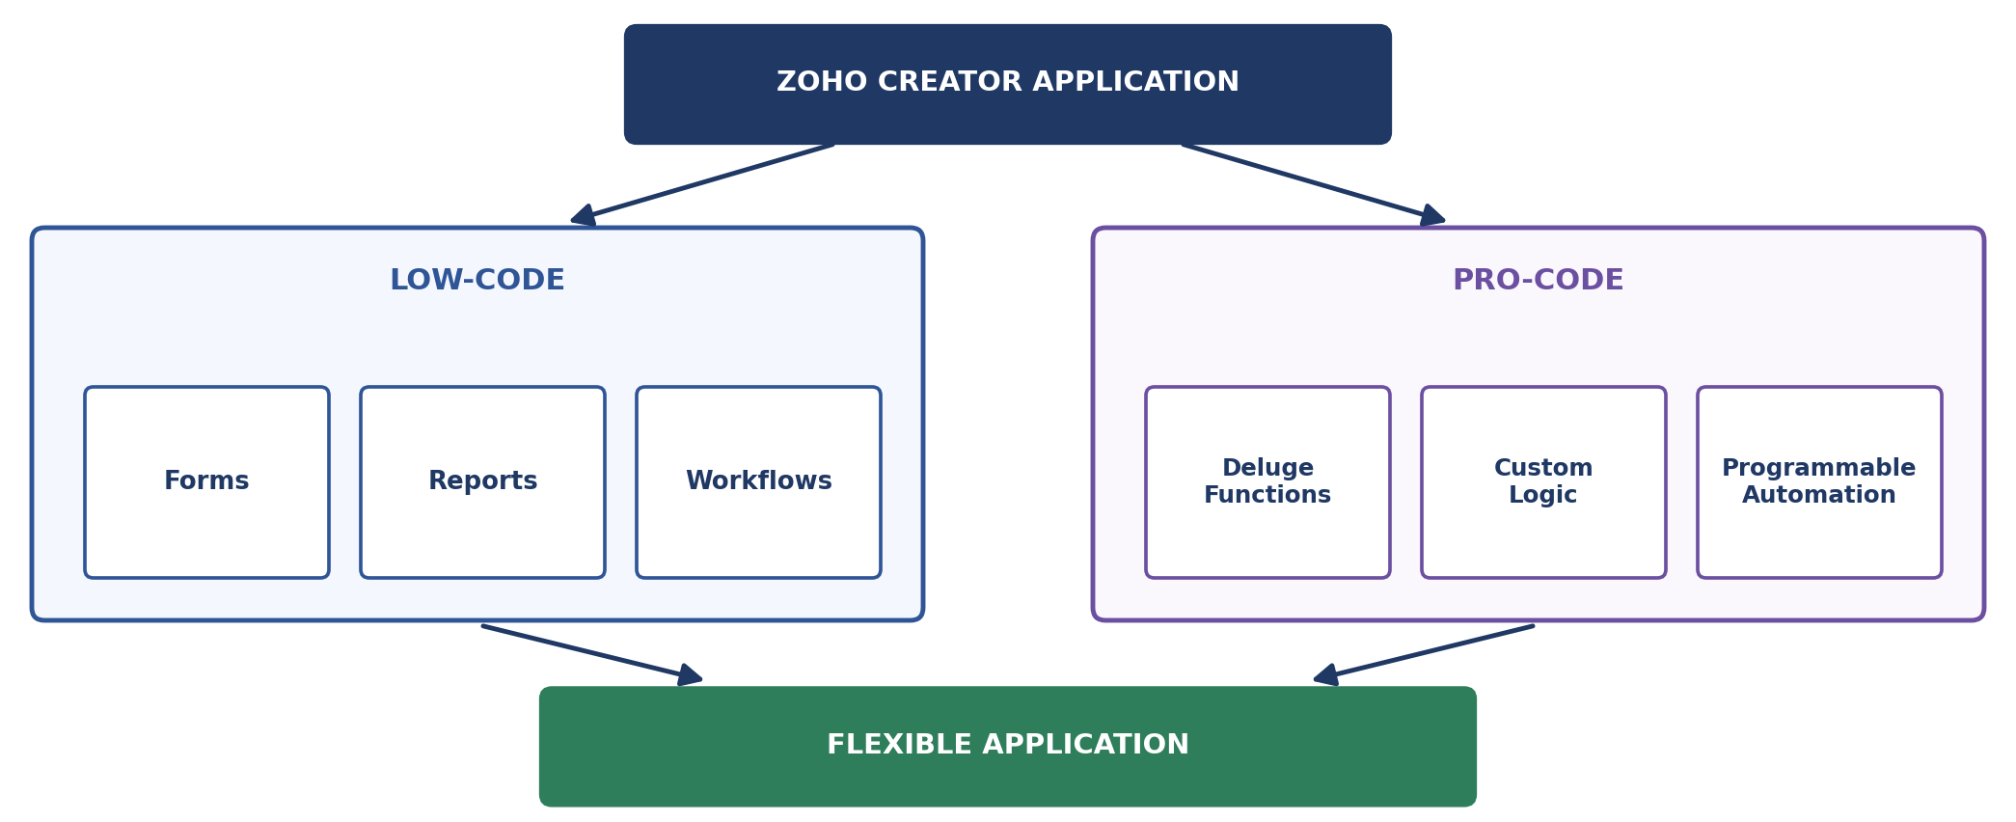
Figure 4: Combined Low-Code and Pro-Code Approach
The comparison shows that low-code development provides the visual application foundation, while pro-code capabilities provide additional programmability and customization.
This experiment demonstrated only a simple custom function returning a confirmation message. It did not implement advanced processing, workflow integration or external system integration, matching the scope of the sample experiment.
RESULT
A custom Deluge function named CheckAppointmentRequest was successfully created in the Patient Appointment & Scheduling Management application using the Default namespace and string return type.
The function was saved, appeared in the Functions section and was executed successfully. It returned the expected confirmation message: “Patient Appointment Request function executed successfully.”
Thus, the experiment successfully demonstrated the basic use of pro-code extension through custom Deluge functions in Zoho Creator.

